Standard ACL Configuration Lab (and OSPFv2)

Overview
This Cisco Packet Tracer lab demonstrates the implementation of traffic filtering using Standard Named Access Control Lists (ACLs) and dynamic routing using OSPFv2.
Two routers connect two separate LAN environments containing user PCs and servers. The lab focuses on enabling end-to-end connectivity with OSPF while enforcing network security policies using standard ACLs.

Objectives
Configure OSPFv2 on R1 and R2.
Advertise directly connected networks into the OSPF domain.
Verify dynamic routing between all LANs.
Configure and apply Standard Named ACLs.
Restrict access to specific server networks according to the required security policies.
Verify ACL functionality using ping tests.

Network Topology
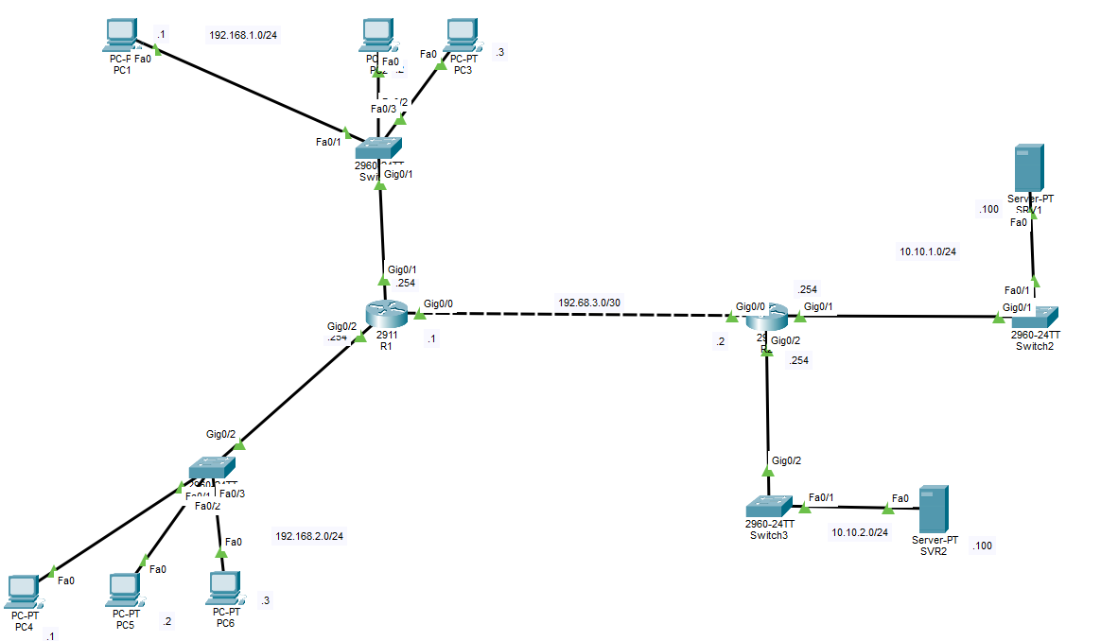

Routers
Cisco 2911 Router (R1)
Cisco 2911 Router (R2)

Switches
Cisco Catalyst 2960 Switches

End Devices
6 PCs
2 Servers

IPv4 Networks
192.168.1.0/24 - PC LAN 1
192.168.2.0/24 - PC LAN 2
192.168.3.0/30 - Router-to-Router Link
10.10.1.0/24 - Server LAN 1
10.10.2.0/24 - Server LAN 2

OSPF Configuration
OSPFv2 was configured on both routers to dynamically exchange routing information.
#router OSPF 1
#network 192.168.1.0 0.0.0.255 area 0
#network 192.168.3.0 0.0.0.3 area 0

Each router advertises only its directly connected networks into Area 0.
Verification
The following commands were used:
show ip ospf neighbor
show ip route
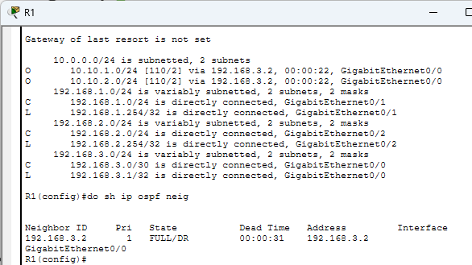
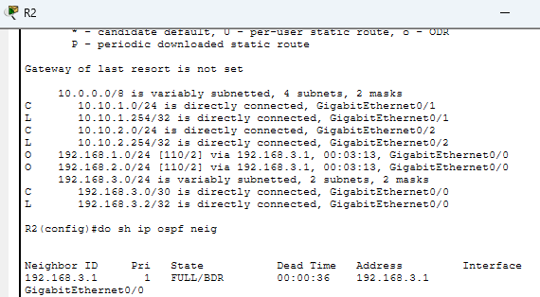

Standard Named ACL Configuration
Standard named ACLs were configured on R2 to enforce the following network security policies.
Implemented Policies/Requirements
- Only PC1, PC2 and PC5 can access 10.10.2.0/24.
- Hosts in 192.168.1.0/24 cannot access 10.10.1.0/24.
- Hosts in 192.168.1.0/24 cannot access 192.168.2.0/24.
- Hosts in 192.168.2.0/24 cannot access 192.168.1.0/24.

- R2
#ip access-list standard TO_10.10.2.0/24
#permit host 192.168.1.1
#permit host 192.168.1.2
#permit host 192.168.2.2
#deny any
#interface g0/2
#ip access-group TO_10.10.2.0/24 out

- R2
#ip access-group standard TO_10.10.1.0/24
#deny 192.168.1.0 0.0.0.255
# permit any
#interface g0/1
#ip access-group TO_10.10.1.0/24 out

- R1
#access-list 1 deny 192.168.1.0 0.0.0.255
#access-list 1 permit any
#interface g0/2
#ip access-group 1 out

- R1
#access-list 2 deny 192.168.2.0 0.0.0.255
#access-list 2 permit any
#interface g0/1
#ip access-group 2 out
ACLs were applied close to the destination networks following Cisco best practices for Standard ACL deployment.
Verification
The following commands were used to verify the configuration:

show access-lists
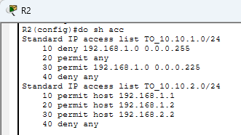
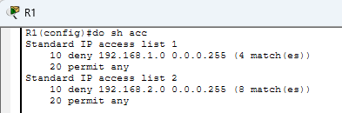

Connectivity was verified using ping
From PC1 to SVR2 | 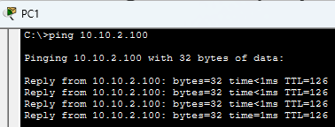
From PC3 to SVR2 | 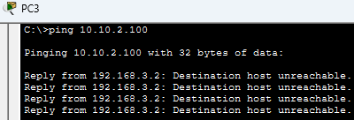
From PC5 to SVR2 | 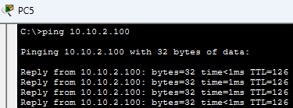
From PC1 to PC5  From PC6 to PC3  Between 2 networks | 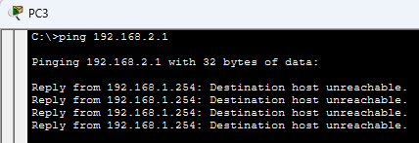  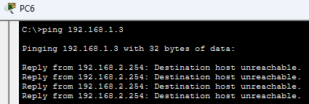

Learning Outcomes
After completing this lab, I was able to:
Advertise directly connected networks using OSPF.
Configure Standard Named ACLs.
Apply ACLs to router interfaces.
Control network access based on source IP addresses.
Troubleshoot routing and ACL-related connectivity issues.

Author
Atajan Rozymuradov

